

Project Synopsis on “**Sales-Analysis”**

Name: Manpreet Singh Goindi

Roll No: 2210993813

# Problem Statement

Supermarkets face challenges in understanding customer preferences, managing inventory efficiently, and optimizing sales strategies due to the vast amount of transactional data. Without proper analysis, businesses struggle to identify key sales drivers, predict demand accurately, and implement effective marketing or operational decisions. This project aims to address these issues by analyzing supermarket sales data to uncover actionable insights, improve revenue generation, and enhance overall business efficiency.

# Introduction

# Supermarket sales analysis examines transaction data to uncover trends, optimizer operations, and improve decision-making.it focus on customer behavior, sales performance and inventory management for enhanced profitability and market competitiveness.

- Customer Behavior Analysis: Identifies purchasing patterns and preferences to improve customer experience.

# - Sales performance Insights: Tracks revenue trends, top-selling products, and preferences to improve customer service

# - Operation Optimization: supports inventory management, pricing strategies, and promotional planning.

# 3 Technology Used

The project will be implemented using the following technologies and libraries:

- *Python:* The core programming language for developing the backend logic.

-*Matplotlib:* A Python library for creating static, animated, and interactive visualizations.

- *Pandas:* A data manipulation library for handling and analyzing structured data.

- *Numpy:* A library for mathematical operations, especially useful for numerical data.

- *Seaborn:* A powerful python library used for data Visualization, built on top of matplotlib.

# Flowchart

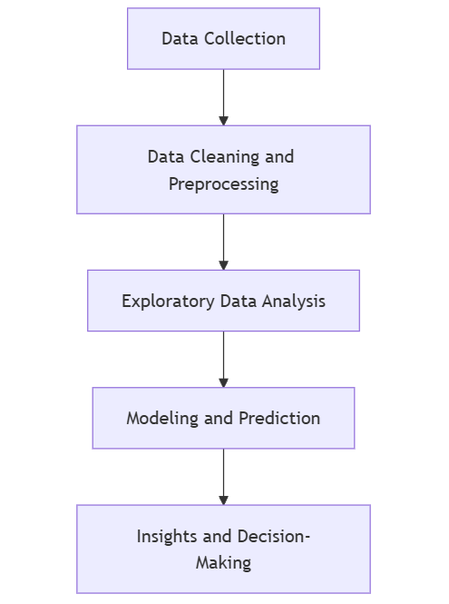

Figure1: flow chart

# References

1. Youtube link for seaborn –

https://www.youtube.com/watch?v=DWVLRhnuGqI&t=369s

1. Chatgpt-

www.chatgpt.com

1. W3schools link used for understanding library-

<https://www.w3schools.com/python/matplotlib_intro.asp>